Sports Club Automation System

Use Case

Information System Design Project

CSE A1

Group: 1

Rolls:

1005001

1005004

1005005

1005007

1005010

Sports Club Automation is an information system for any sports club in Bangladesh to manage and automate the whole system. This system can be a platform for administrator, all the stuffs, players and people related to the club.

Use Case analysis is an important task for information system design. Subsystems of the main system include use cases. The subsystems of our proposed systems are:

**Subsystem:**

* Communication
* Registration
* Social Interaction
* Team Management
* Online Store

**Actors:**

Actors play an important role for the whole system. The actors for our system are:

* Management Board
* Manager
* Coach
* Stuff
* Player
* Fan
* Finance Manager
* Online Product Manager
* Warehouse Manager
* Buyer
* Admin
* Public

**Actor Glossary:**

Actor and their key names used in the use-case narratives.

|  |  |
| --- | --- |
| **Actor** | **Short-key** |
| Board | BRD |
| Manager | MGR |
| Coach | CH |
| Stuff | STF |
| Player | PLR |
| Fan | FN |
| Finance Manager | FMGR |
| Online Product Manager | PMGR |
| Warehouse Manager | WMGR |
| Buyer | BYR |
| Admin | ADMIN |
| Public | PUBLIC |

**1. Communication Subsystem**

|  |  |  |  |
| --- | --- | --- | --- |
| Use-Case ID | Name | Description | Participant Actors and Roles |
| 1.1 | Login | Log into member account | BRD, MGR, CH, PLR, STF can log into system via internet or mobile app |
| 1.2 | Club Communication | Communicate between club members, send messages | BRD, MGR, CH, PLR, STF can contact with one another |
| 1.3 | Notification | Notify members of different events and activities | BRD, MGR, CH, PLR, STF are notified different events |
| 1.4 | Complain | Complain to coach, manager or Board | MGR, CH, PLR, STF can complain to respective higher ranks |

**Use-Case Diagram of Communication Subsystem**

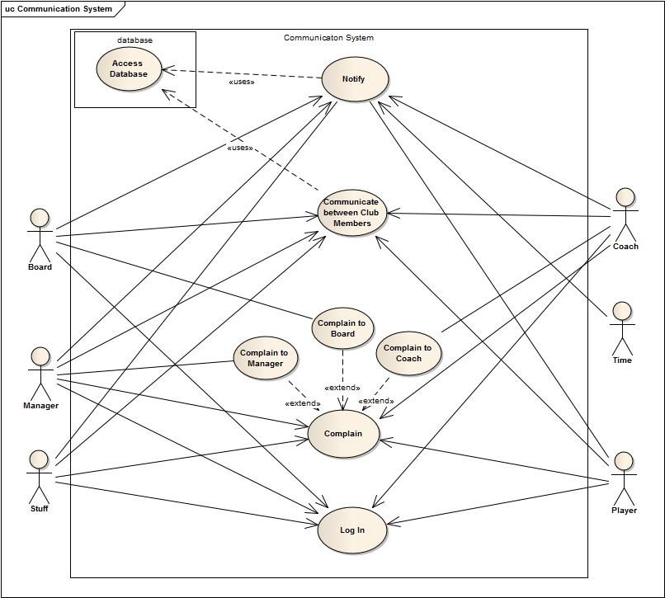

**1.1 Login**

|  |  |
| --- | --- |
| **Use-Case name** | **Define route and price** |
| Use-Case ID | 1.1 |
| Priority | High |
| Primary Business Actor | BRD, MGR, CH, PLR, STF |
| Primary System Actor | BRD, MGR, CH, PLR, STF |
| Description | Actors can log in to account in the system via internet or mobile app |
| Trigger | Anyone of BRD, MGR, CH, PLR, STF |

**Typical course of events**

|  |  |
| --- | --- |
| **Actor Action** | **System Action** |
| 1. Attempt to log in to system from internet or mobile app | 2. Verification and log in |
|  | 3. Show account to actor |
| 4. Access personal account |  |

**Documentation of the use-case (1.1) course of events**

* **Conclusion:** concludes when logged into account
* **Post-condition:** show actor the respective personal account to access communication
* **Implementation issues:** GUI will be provided in the website to log in, a Mobile app will be provided to log in from mobile devices

**1.2 Club Communication**

|  |  |
| --- | --- |
| **Use-Case name** | **Define route and price** |
| Use-Case ID | 1.2 |
| Priority | High |
| Primary Business Actor | BRD, MGR, CH, PLR, STF |
| Primary System Actor | BRD, MGR, CH, PLR, STF |
| Description | Actors can communicate with one another by mobile & mail service according to their domain of access |
| Trigger | Anyone of BRD, MGR, CH, PLR, STF |

**Typical course of events**

|  |  |
| --- | --- |
| **Actor Action** | **System Action** |
| 1. Access personal account to view events, schedule, activities and send messages or mail | 2. System uses database to get information of members upon request |
|  | 3. Messages or mail is sent to appropriate personnel |
|  | 4. Notifies sender |
| 5. Sender receives confirmation |  |

**Documentation of the use-case (1.2) course of events**

* **Conclusion:** concludes when a message or mail is sent or logged out from account
* **Implementation issues:** GUI for personal account, information, sending message or mail will be provided.

**1.3 Notification**

|  |  |
| --- | --- |
| **Use-Case name** | **Define route and price** |
| Use-Case ID | 1.3 |
| Priority | High |
| Primary Business Actor | BRD, MGR, CH, PLR, STF |
| Primary System Actor | TME, BRD, MGR, CH |
| Description | Actors are notified by the system via mobile and mail of messages, events and activities |
| Trigger | TME, BRD, MGR, CH |

**Typical course of events**

|  |  |
| --- | --- |
| **Actor Action** | **System Action** |
|  | 1. System sends notification to accounts |
| 2. Receives notification through mobile or after logging into account |  |

**Documentation of the use-case (1.3) course of events**

* **Conclusion:** concludes when actor receives notification
* **Implementation issues:** Notification will be shown in GUI in the personal account

**1.4 Complaint**

|  |  |
| --- | --- |
| **Use-Case name** | **Define route and price** |
| Use-Case ID | 1.4 |
| Priority | Medium |
| Primary Business Actor | BRD, MGR, CH |
| Primary System Actor | MGR, CH, PLR, STF |
| Description | PLR and STF can complain to CH, MGR; CH, MGR can complain to BRD |
| Trigger | MGR, CH, PLR, STF |

**Typical course of events**

|  |  |
| --- | --- |
| **Actor Action** | **System Action** |
| 1. Write complain |  |
| 2. Submit complain to CH, MGR or BRD according to their access of permission | 3. Sends the complain to requested actor |
|  | 4. Confirms complainer |

**Documentation of the use-case (1.4) course of events**

* **Conclusion:** concludes when a complaint is sent to appropriate personnel
* **Post-condition:** Authority takes suitable steps for the complaint
* **Implementation issues:** GUI to write and submit complaint will be provided

**2. Registration Subsystem**

|  |  |  |  |
| --- | --- | --- | --- |
| **Use-Case ID** | **Name** | **Description** | **Participant Actors and Roles** |
| 2.1 | Registration | New registration by players or fans | PLR, FN registers |
| 1.2 | Confirmation | ADMIN confirms registration | ADMIN confirm or reject registration |

**Use-Case Diagram of Registration**

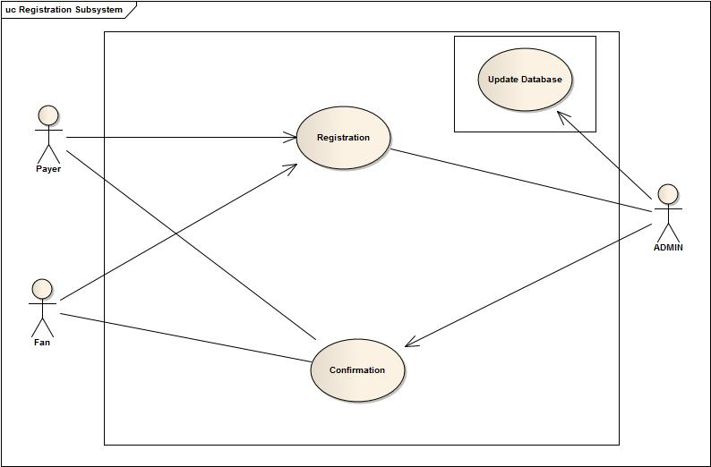

**2.1 Registration**

|  |  |
| --- | --- |
| **Use-Case name** | **Define route and price** |
| Use-Case ID | 2.1 |
| Priority | High |
| Primary Business Actor | ADMIN |
| Primary System Actor | PLR, FN |
| Description | PLR, FN register and request goes to ADMIN |
| Trigger | PLR, FN |

**Typical course of events**

|  |  |
| --- | --- |
| **Actor Action** | **System Action** |
| 1. PLR, FN registers | 2. Request is sent to ADMIN |
| 3. ADMIN receives request |  |

**Documentation of the use-case (2.1) course of events**

* **Conclusion:** Concludes when ADMIN receives request
* **Post-condition:** Registration data is saved to system
* **Implementation issues:** GUI will be provided to Player or fan for registration

**2.2 Confirmation**

|  |  |
| --- | --- |
| **Use-Case name** | **Define route and price** |
| Use-Case ID | 2.2 |
| Priority | High |
| Primary Business Actor | PLR, FN |
| Primary System Actor | ADMIN |
| Description | ADMIN confirms (accepts or rejects) registration |
| Trigger | ADMIN |

**Typical course of events**

|  |  |
| --- | --- |
| **Actor Action** | **System Action** |
| 1. ADMIN confirms request | 2. Confirmation data is saved to system |
|  | 3. Confirmation is sent to requester |

**Documentation of the use-case (2.2) course of events**

* **Conclusion:** concludes when confirmation is sent to requester
* **Post-condition:** registration phase ends

**3. Social Interaction System**

|  |  |  |  |
| --- | --- | --- | --- |
| **Use-Case ID** | **Name** | **Description** | **Participant Actors and Roles** |
| 3.1 | Login | Log into member account | FAN can log into personal account via internet |
| 3.2 | Entertainment | Entertainment facilities for supporters | ADMIN may provide options for entertainment and FAN can use them |
| 3.3 | Update website | Update website after winner selection | ADMIN will update website |

**Use-Case Diagram of Social Interaction System**

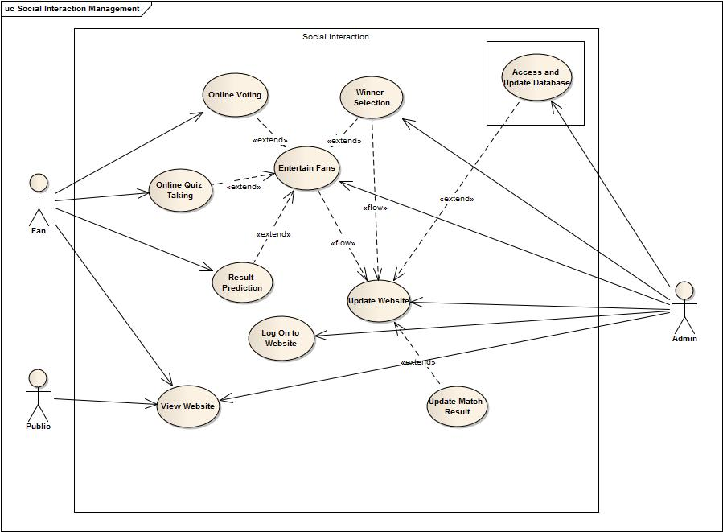

**3.1 Login**

|  |  |
| --- | --- |
| **Use-Case name** | **Define route and price** |
| Use-Case ID | 3.1 |
| Priority | High |
| Primary Business Actor | FAN |
| Primary System Actor | ADMIN, FAN |
| Description | FAN can log into their personal account |
| Trigger | ADMIN, FAN |

**Typical course of events**

|  |  |
| --- | --- |
| **Actor Action** | **System Action** |
| 1. Attempt to log in to system from internet | 2. Verification and log in |
|  | 3. Show account to actor |
| 4. Access entertainment section of website |  |

**Documentation of the use-case (3.1) course of events**

* **Conclusion:** concludes when logged into account
* **Post-condition:** show actor the options he may participate
* **Implementation issues:** GUI will be provided in the website to log in and for participation in different game or contest

**3.2 Entertainment**

|  |  |
| --- | --- |
| **Use-Case name** | **Define route and price** |
| Use-Case ID | 3.2 |
| Priority | High |
| Primary Business Actor | FAN |
| Primary System Actor | ADMIN |
| Description | ADMIN will provide different options for entertainment, FAN can be entertained |
| Trigger | ADMIN |

**Typical course of events**

|  |  |
| --- | --- |
| **Actor Action** | **System Action** |
| 1. Participate in quiz, voting etc | 2. Update data for different contest |
|  | 3. Check time to stop game or contest |
|  | 4. Announce winner |

**Documentation of the use-case (3.2) course of events**

* **Conclusion:** Concludes when winner of contest or game is announced
* **Post-condition:** Update database and website to publish winner
* **Implementation issues:** A section in website to publish winner’s info

**3.3 Update Website**

|  |  |
| --- | --- |
| **Use-Case name** | **Define route and price** |
| Use-Case ID | 3.3 |
| Priority | High |
| Primary Business Actor | PUBLIC |
| Primary System Actor | ADMIN |
| Description | ADMIN will update website |
| Trigger | ADMIN |

**Typical course of events**

|  |  |
| --- | --- |
| **Actor Action** | **System Action** |
| 1. Update database after match-day, new fan member addition, winner of game selected | 2. Updates website from database |

**Documentation of the use-case (3.3) course of events**

* **Conclusion:** concludes when admin updates website
* **Implementation issues:** GUI for admin to publish news in website

**4. Team Management**

|  |  |  |  |
| --- | --- | --- | --- |
| **Use-Case ID** | **Name** | **Description** | **Participant Actors and Roles** |
| 4.1 | Registration | Register team members in the transfer window and assign task to staff | MGR to register PLR and assign task to STF |
| 4.2 | Squad selection | Selection of squad of 20 members before match-day | MGR,CH to select squad |
| 4.3 | Evaluation | Accessing data of players and staff | MGR,CH,STF can access data of PLR, STF |
| 4.4 | Schedule Management | Managing schedule for training and others | BRD, MGR,CH will determine schedule and PLR,STF will be informed |

**Use-Case Diagram of Team Management**

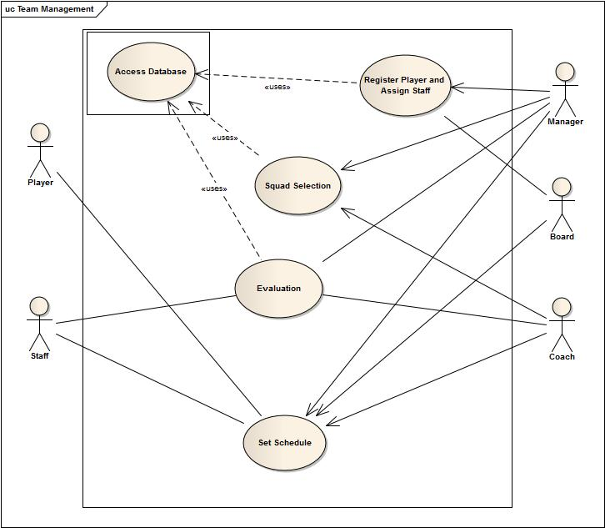

**4.1 Registration**

|  |  |
| --- | --- |
| **Use-Case name** | **Define route and price** |
| Use-Case ID | 4.1 |
| Priority | High |
| Primary Business Actor | PLR |
| Primary System Actor | MGR |
| Description | MGR would complete registration process of PLR and assign task to STF |
| Trigger | MGR |

**Typical course of events**

|  |  |
| --- | --- |
| **Actor Action** | **System Action** |
| 1. Registration form of a player is submitted | 2. Update database with the players info |

**Documentation of the use-case (4.1) course of events**

* **Conclusion:** concludes when database is updated with players’ info

**4.2 Squad Selection**

|  |  |
| --- | --- |
| **Use-Case name** | **Define route and price** |
| Use-Case ID | 4.2 |
| Priority | High |
| Primary Business Actor | PLR |
| Primary System Actor | MGR, CH |
| Description | MGR,CH select squad for next match |
| Trigger | MGR, CH |

**Typical course of events**

|  |  |
| --- | --- |
| **Actor Action** | **System Action** |
| 1. Access Database and select players for next match | 2. Update database with selected squad |

**Documentation of the use-case (4.2) course of events**

* **Conclusion:** concludes when database is updated with selected players
* **Implementation issues:** GUI for all players list and to select squad will be provided

**4.3 Evaluation**

|  |  |
| --- | --- |
| **Use-Case name** | **Define route and price** |
| Use-Case ID | 4.3 |
| Priority | High |
| Primary Business Actor | STF, PLR, CH |
| Primary System Actor | MGR, CH, BRD |
| Description | Retrieving data from database about players condition, progress and updating weekly evaluation |
| Trigger | MGR, CH, BRD |

**Typical course of events**

|  |  |
| --- | --- |
| **Actor Action** | **System Action** |
| 1. Requests to view data about particular youth player | 2. System sends data about that player |
| 3. Evaluate player according to performance and training | 4. System sends evaluation to players account |

**Documentation of the use-case (4.3) course of events**

* **Conclusion:** concludes when system sends information to players account
* **Implementation issues:** GUI will be provided for weekly evaluation

**4.4 Schedule Management**

|  |  |
| --- | --- |
| **Use-Case name** | **Define route and price** |
| Use-Case ID | 4.4 |
| Priority | High |
| Primary Business Actor | CH, MGR, PLR, STF |
| Primary System Actor | PLR, STF |
| Description | MGR, CH manage schedule for PLR, STF |
| Trigger | BRD, PLR, MGR |

**Typical course of events**

|  |  |
| --- | --- |
| **Actor Action** | **System Action** |
| 1. Update Schedule | 2. System notifies the change in actor’s account |

**Documentation of the use-case (4.4) course of events**

* **Conclusion:** concludes when system notifies changes in player account

**5. Online Store Subsystem**

|  |  |  |  |
| --- | --- | --- | --- |
| **Use-Case ID** | **Name** | **Description** | **Participant Actors and Roles** |
| 1.1 | Update Product | Updating product information: price, quantity etc. | WMGR and PMGR updates product information |
| 1.2 | View Product | Shows available products in the online store | Buyers can view products in the store |
| 1.3 | Product Booking | Booking for products, includes fancy club products and tickets | Buyers can book products or tickets |
| 1.4 | Confirmation or cancelation | Confirmation or cancelation of booking | WMGR or PMGR confirms booking. After certain amount of time booking is cancelled. |

**Use-Case Diagram of Online Store Subsystem**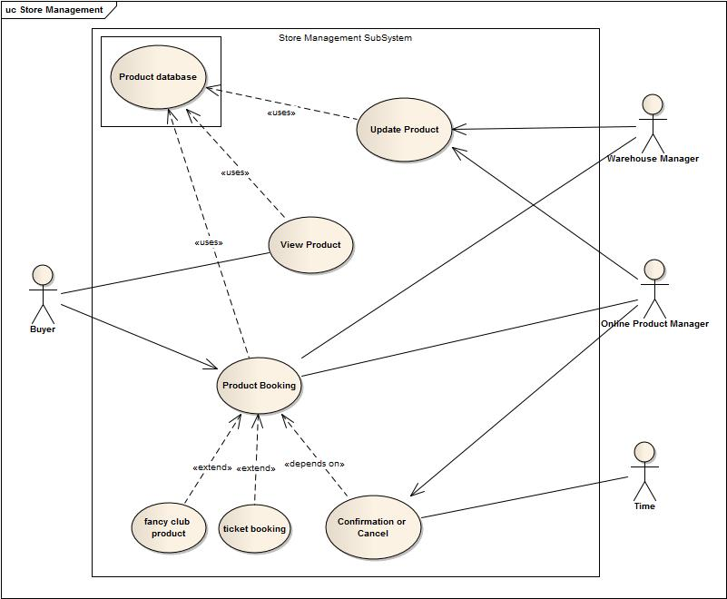

**5.1 Update Product**

|  |  |
| --- | --- |
| **Use-Case name** | **Define route and price** |
| Use-Case ID | 5.1 |
| Priority | High |
| Primary System Actor | WMGR, PMGR |
| Description | Actors can update information of products |
| Trigger | WMGR, PMGR |

**Typical course of events**

|  |  |
| --- | --- |
| **Actor Action** | **System Action** |
| 1. Updates information of products | 2. Stores information in product database |

**Documentation of the use-case (5.1) course of events**

* **Conclusion:** concludes when product information is updated
* **Post-condition:** Shows updated information in the View Product
* **Implementation issues:** GUI will be provided to update information of products

**5.2 View Product**

|  |  |
| --- | --- |
| **Use-Case name** | **Define route and price** |
| Use-Case ID | 5.2 |
| Priority | High |
| Primary Business Actor | BYR |
| Primary System Actor | BYR |
| Description | BYR can view available products and tickets from store |
| Trigger | BYR |

**Typical course of events**

|  |  |
| --- | --- |
| **Actor Action** | **System Action** |
| 1. BYR requests to view product in the online store | 2. Shows available products form product database |

**Documentation of the use-case(5.2) course of events**

* **Conclusion:** concludes when a buyer books products or leaves the store
* **Post-condition:** If buyer books a product, then information is sent to Product Manager and Warehouse Manager
* **Implementation issues:** GUI of online store will be provided

**5.3 Product Booking**

|  |  |
| --- | --- |
| **Use-Case name** | **Define route and price** |
| Use-Case ID | 5.3 |
| Priority | High |
| Primary Business Actor | BYR |
| Primary System Actor | BYR, PMGR, WMGR |
| Description | BYR can book products or tickets online |
| Trigger | TME, BRD, MGR, CH |

**Typical course of events**

|  |  |
| --- | --- |
| **Actor Action** | **System Action** |
| 1. Views and books product or ticket | 2. Sends information to PMGR, WMGR about booking |
|  | 3. Confirms buyer about the booking status. |

**Documentation of the use-case (5.3) course of events**

* **Conclusion:** concludes when system confirms about booking
* **Post-condition:** send information to PMGR and WMGR

**5.4 Confirmation**

|  |  |
| --- | --- |
| **Use-Case name** | **Define route and price** |
| Use-Case ID | 5.4 |
| Priority | High |
| Primary Business Actor | BYR |
| Primary System Actor | PMGR, TIME |
| Description | PMGR confirms about booking. After certain amount of time booking is cancelled and notified |
| Trigger | PMGR, TIME |

**Typical course of events**

|  |  |
| --- | --- |
| **Actor Action** | **System Action** |
|  | 1. Checks availability and confirms and notifies PMGR |
| 2. PMGR accepts confirmation | 3. Sends confirmation to buyer |
| 4. Cancels booking if time is over(optional) | 5. Notifies buyer that booking is cancelled(optional) |

**Documentation of the use-case (5.4) course of events**

* **Conclusion:** concludes when booking product is bought or booking is cancelled
* **Post-condition:** Notify buyer about booking confirmation/cancelation